

Operating Systems & Architecture

VIRTUAL WINDOWS ACTIVE DIRECTORY / NETWORK SERVER VIRTUALIZATION

STUDENT: DIANA CABEZAS. STUDENT #: 2023073. DATE: 14.05.2023

Table of Contents

1.) Setting up the resources and network users. 3

a.) DigiTech has two departments. Using Active Directory Users and Computers (ADUC), create 2 departments (Organizational Units) called Accounting-Dublin and Sales-Dublin 3

b.) Inside the Accounting-Dublin OU create a Global Security group called Accounting and then create the 5 Accounting users accounts shown below, using the names supplied. 4

c.) Inside each departmental OU (Accounting-Dublin and Sales-Dublin), create and share two folders (one for each department) and apply permissions as specified below: 7

d.) Test the permissions for both the Sales-Documents folder and the Accounting-Documents folder by logging onto the Web computer by using a user account from Dublin-Sales or a user account from Dublin-Accounting. 12

e.) Apply a suitable password policy and an account lockout policy for the entire domain. 16

2.) Setting Up a DHCP Server for the Domain. 17

3.) Configuring RAID on the Web Server. 26

Your supervisor at DigiTech is concerned that the files on the Web server could accidentally deleted and they would like to see some fault tolerance added to the Web server computer. 26

4.) The tasks above provide a foundation for a network infrastructure. 29

a.) The IT manager would like each department to have their own custom wallpaper for the user desktop. 29

b.) The users in both the Sales department and the accounting department have been making unauthorized changes to their systems using the Control Panel. 32

c.) Automated Software installation. 34

5.) PowerShell scripting 37

Challenges: 41

References: 41

# Setting up the resources and network users.

## DigiTech has two departments. Using Active Directory Users and Computers (ADUC), create 2 departments (Organizational Units) called Accounting-Dublin and Sales-Dublin

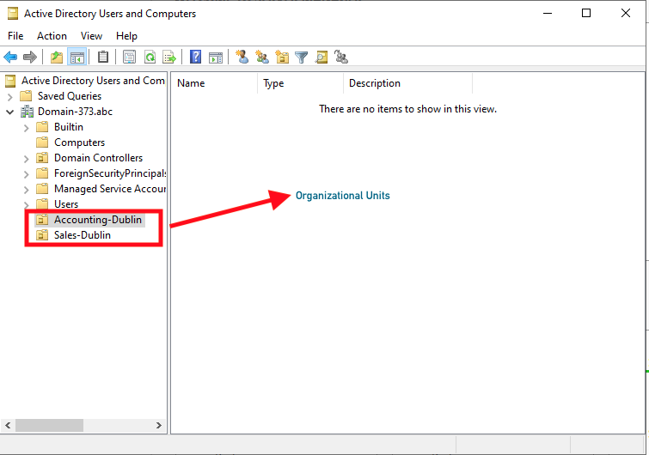

## Inside the Accounting-Dublin OU create a Global Security group called Accounting and then create the 5 Accounting users accounts shown below, using the names supplied.

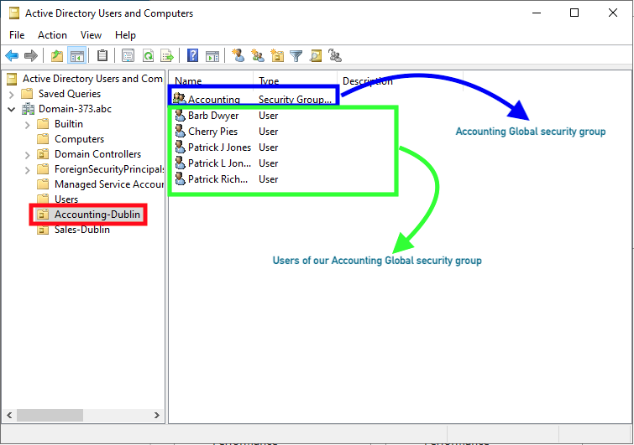

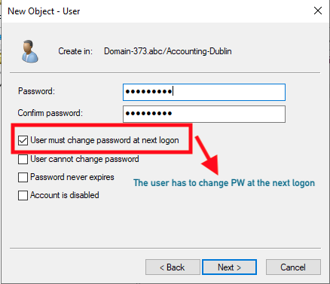

1. Inside the Sales-Dublin OU create a Global Security group called Sales and then create the 5 Sales users accounts shown below, using the names supplied.

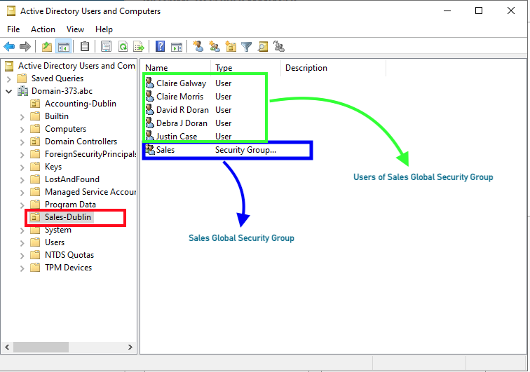

1. Use ADUC to add each of the 10 users to their groups (Accounting and Sales).

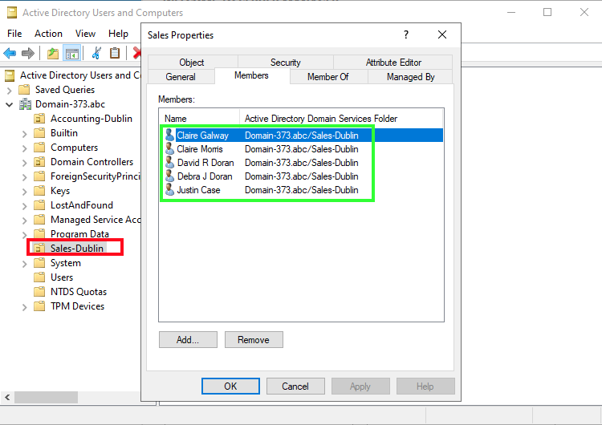

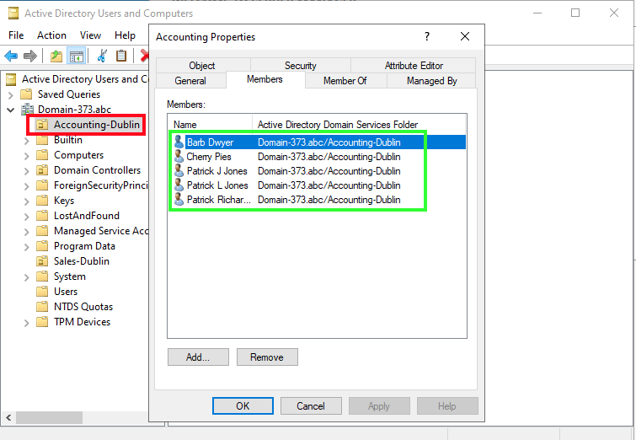

## Inside each departmental OU (Accounting-Dublin and Sales-Dublin), create and share two folders (one for each department) and apply permissions as specified below:

Create one folder for each department (Sales-Documents for the sales department and Accounting-Documents for the accounting department).

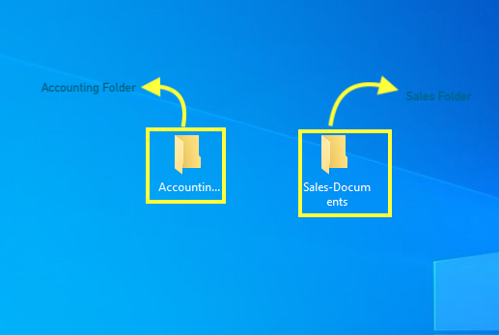

Share each of the folders applying permissions as follows:

You will apply both Share permissions and NTFS permissions.

Give the Accounting group Full Control permissions for the Accounting-Documents folder.

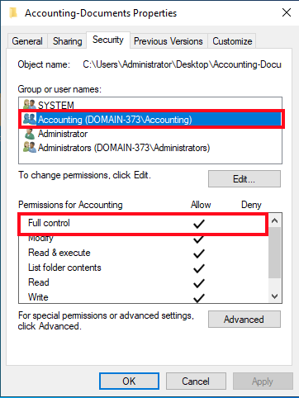

The Sales group should have Full Control permissions for the Sales-Documents folder.

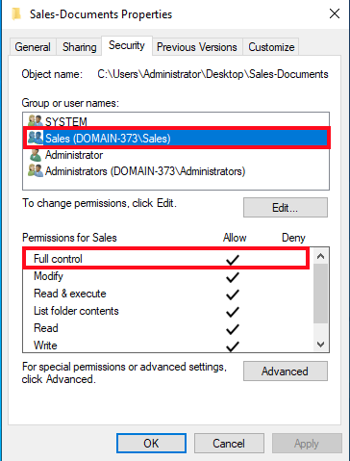

You should remove the Everyone group when applying the share permissions. Note: you will need to set the permissions on both the Share and Security tabs.

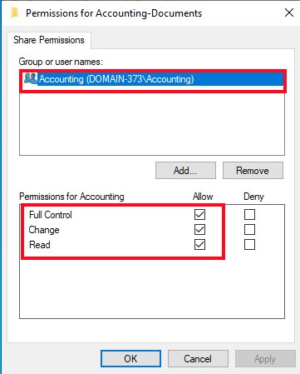

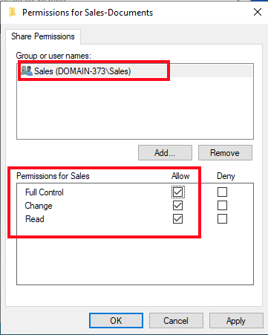

## Test the permissions for both the Sales-Documents folder and the Accounting-Documents folder by logging onto the Web computer by using a user account from Dublin-Sales or a user account from Dublin-Accounting.

Use UNC format to check the permissions for both resources: \\Server-name\Share-name If the permissions do not work, go back to the Domain Controller, and troubleshoot!

Testing the resources permissions: You should be able to demonstrate that the permissions are working for both the Sales and the Account folders. For example, if you log onto the Web server as a member of the Sales group, you should be able to access the Sales-Documents folder but have Access Denied on the Accounting folder.

----------------------------------------ACCOUNTING-TEST-------------------------------------------------

If asked to change the password during the first log-in, use pass1234$ for the password as we have been using.

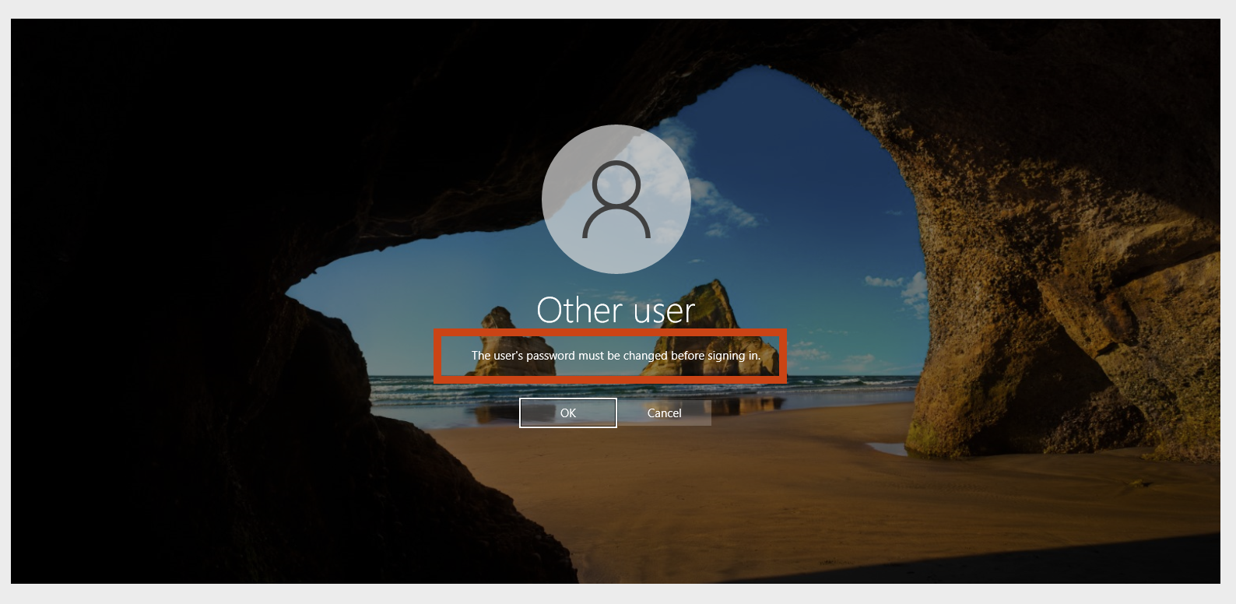

Use UNC format to check the permissions for both resources: \\Server-name\Share-name

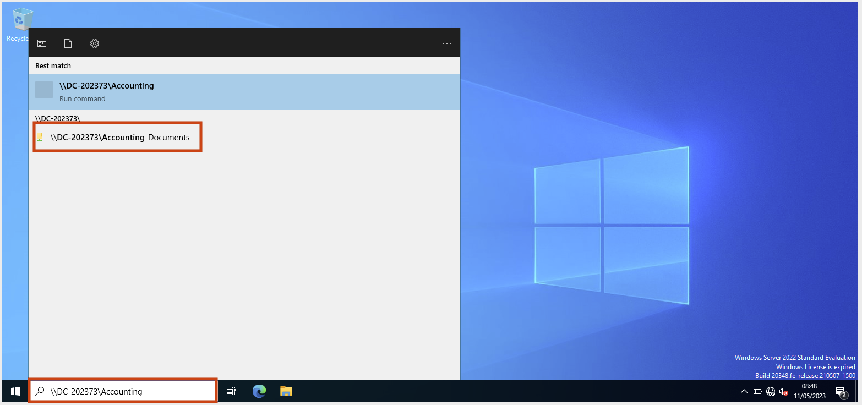

Accounting-Dublin user should be able to access Accounting-Documents.

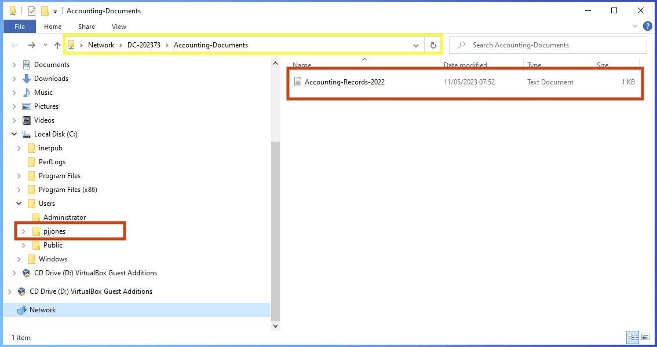

But not Sales-Documents.

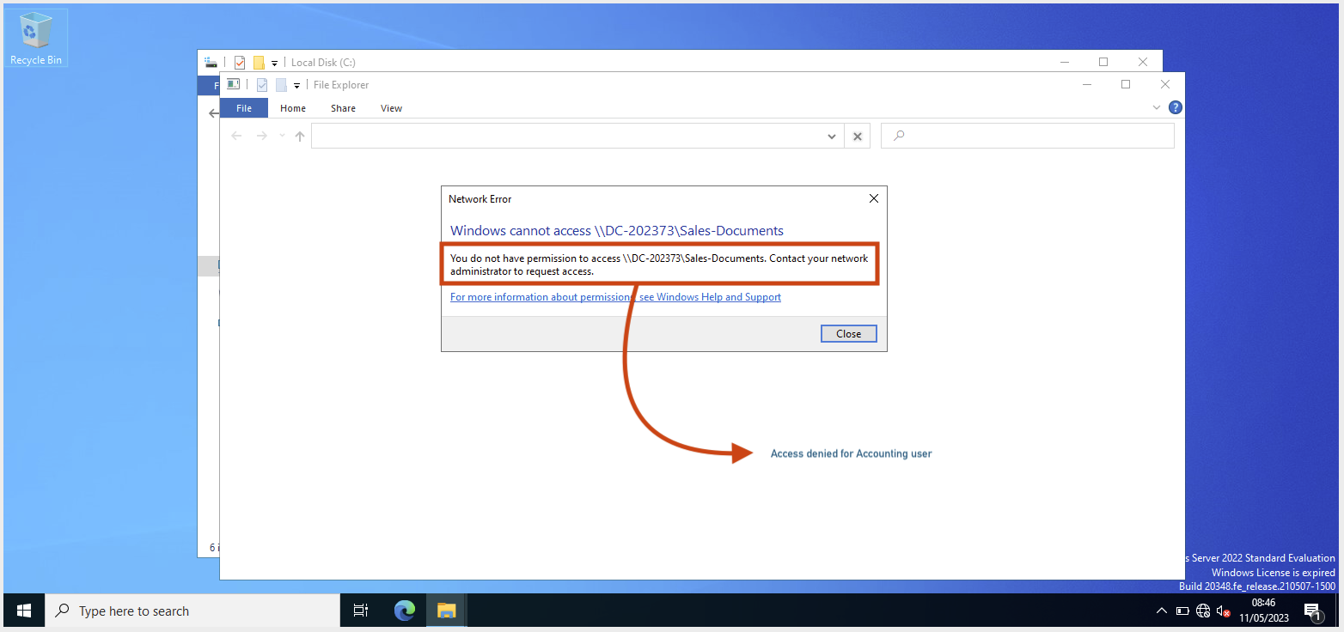

------------------------------------------SALES-TEST---------------------------------------------------------

Use UNC format to check the permissions for both resources: \\Server-name\Share-name

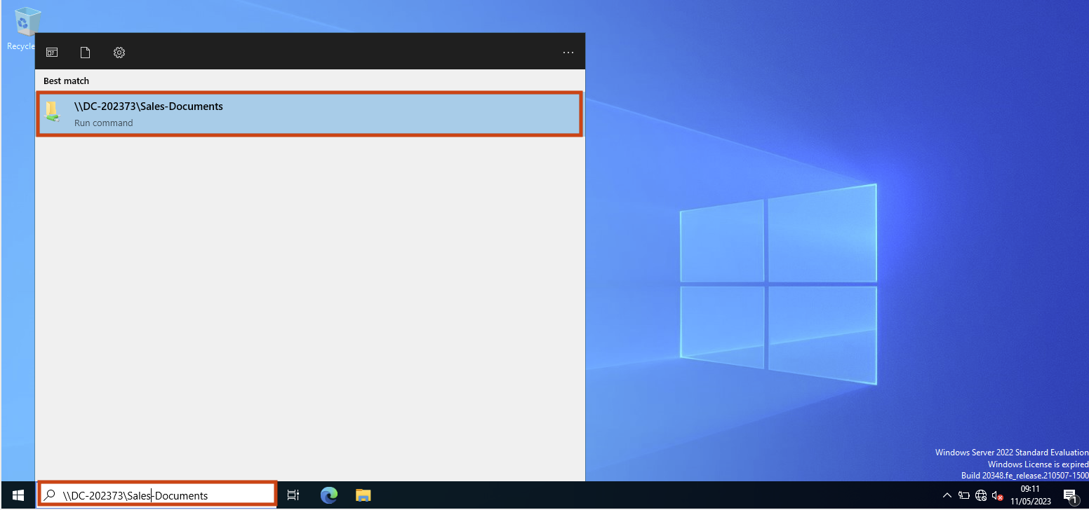

Sales-Dublin user should be able to access Sale-Documents.

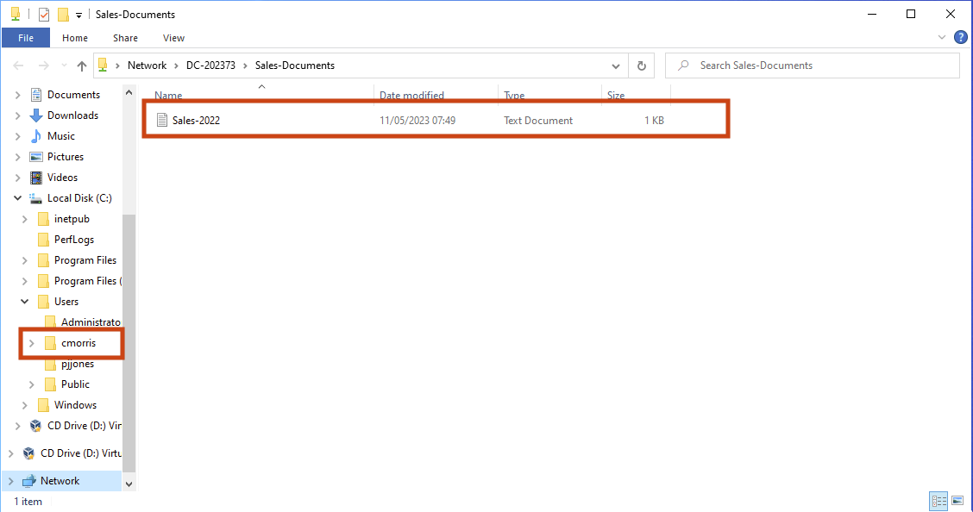

But not Accounting-Documents.

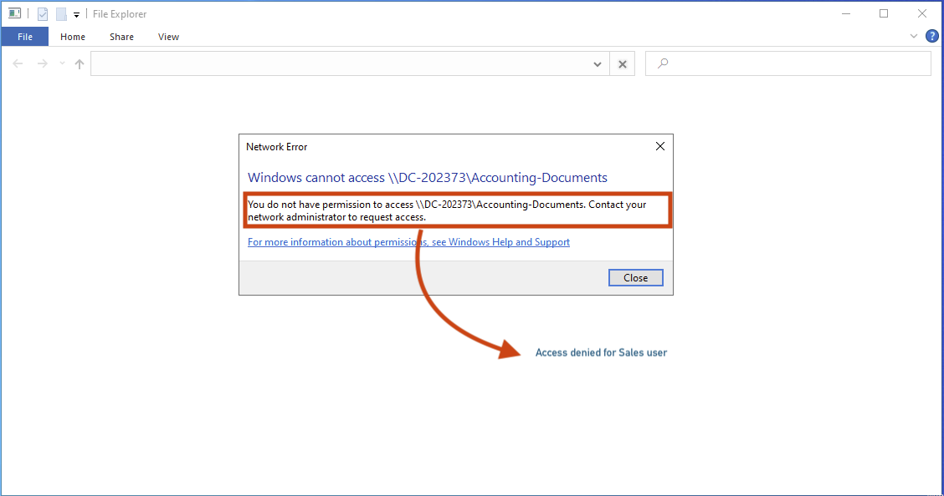

## Apply a suitable password policy and an account lockout policy for the entire domain.

Ensure that there is a feature to lock the account after a number of failed attempts.

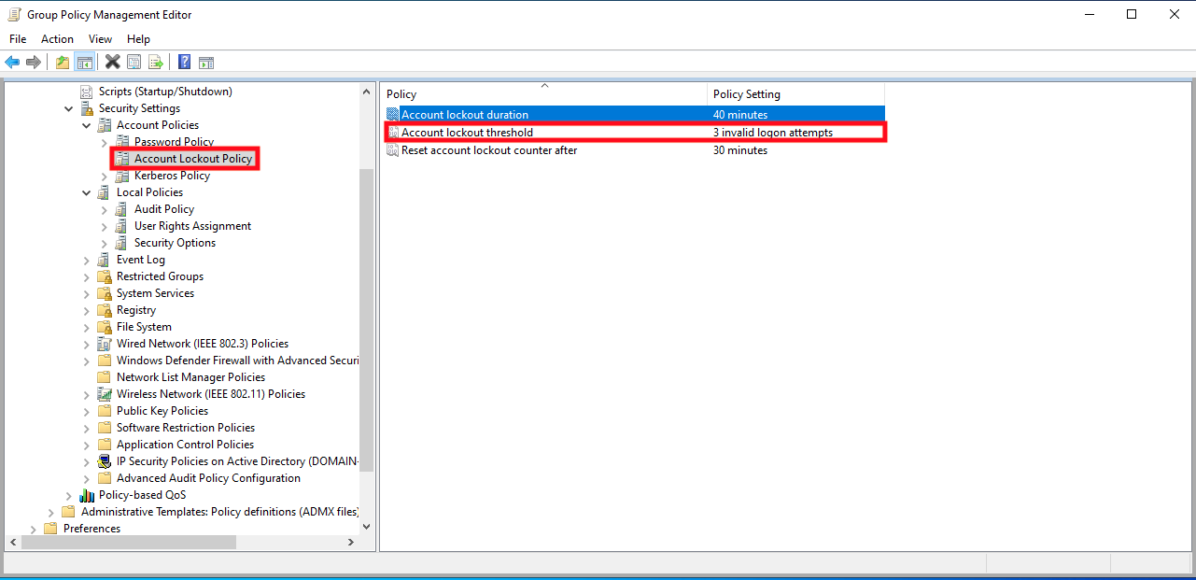

Feature that will require the user to change their password every 30 days.

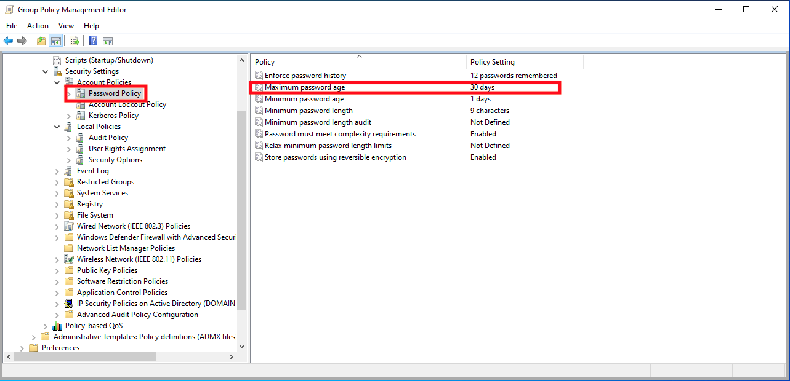

# Setting Up a DHCP Server for the Domain.

Your supervisor at DigiTech needs to have dynamic addresses assigned to all of the client computers in the network.

Add the DHCP server role to the Domain Controller server computer using the Add Roles and Features in the Server Manager console [for this project, you do not need to add support for WINS or IPv6].

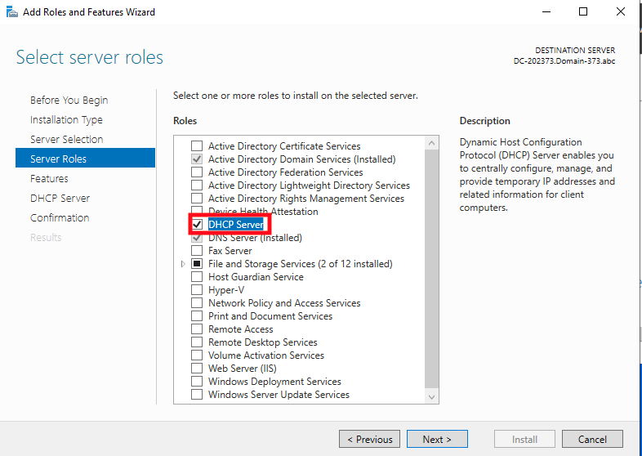

DHCP server installed.

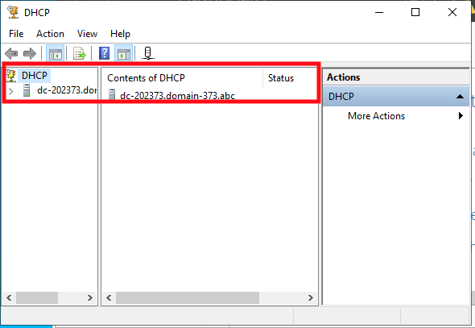

1. Configure DHCP using the DHCP console in Administrative Tools.

Use to following range of IP addresses for the IP Address Scope: The DHCP Scope Name should be the name of your Domain (such as Domain-123).

Starting IP address is 172.16.0.1 / Ending IP address is 172.16.0.254

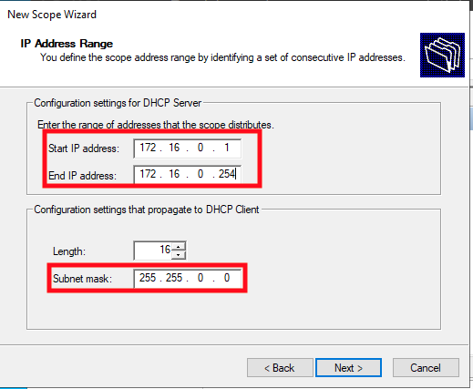

The subnet mask should be /16 and the default gateway should be 172.16.0.1.

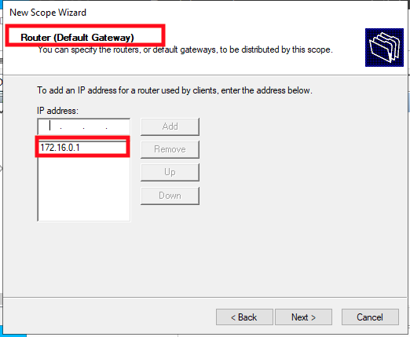

The DNS server address should be 172.16.0.100.

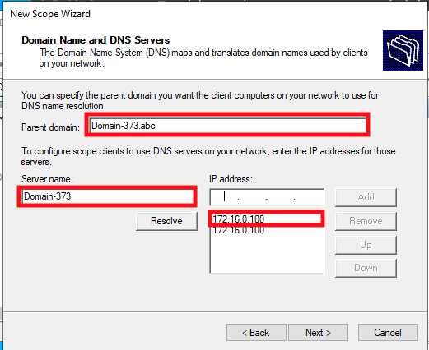

The lease duration should be for 24 hours.

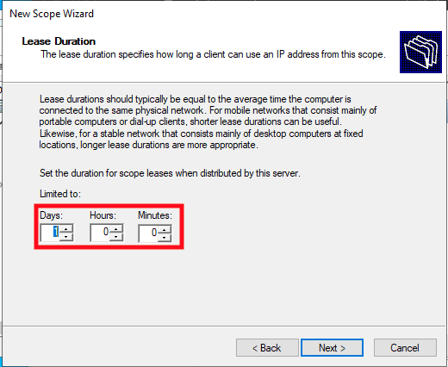

You will need to create four DHCP address exclusions.

In the Address Pool create the following four exclusion ranges:

From 172.16.0.1 to 172.16.0.1

From 172.16.0.50 to 172.16.0.50

From 172.16.0.100 to 172.16.0.100

From 172.16.0.200 to 172.16.0.200

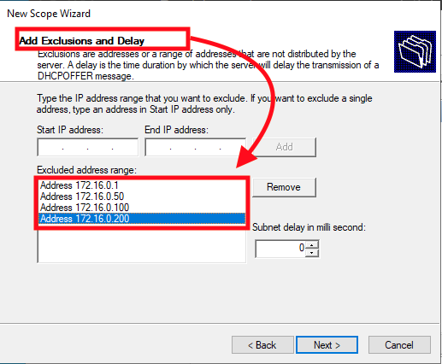

1. You will also need to create an address reservation for the Web computer… from Administrative Tools access the DHCP console.

In the Web computer find the MAC address of the Network Card (IPCONFIG/ ALL)

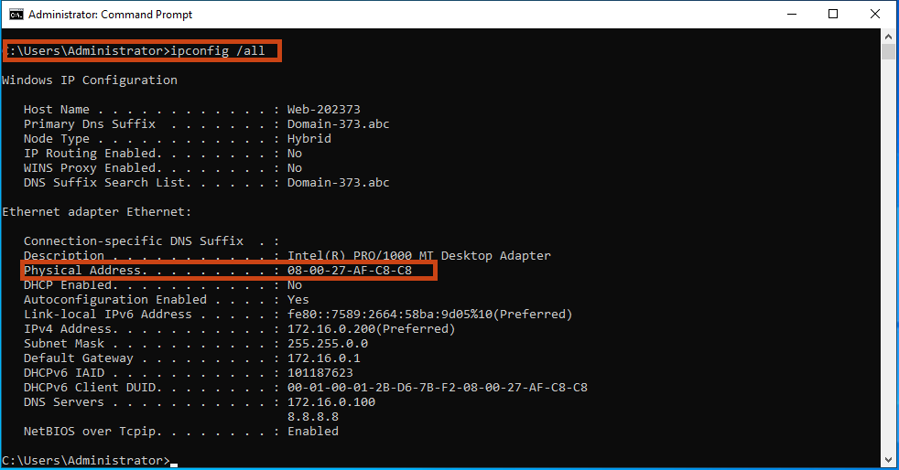

And then go to the DHCP console and make a reservation called Web 2023xyz where xyz are last digits of your student number and assign the IP address of 172.16.0.50 (description optional)

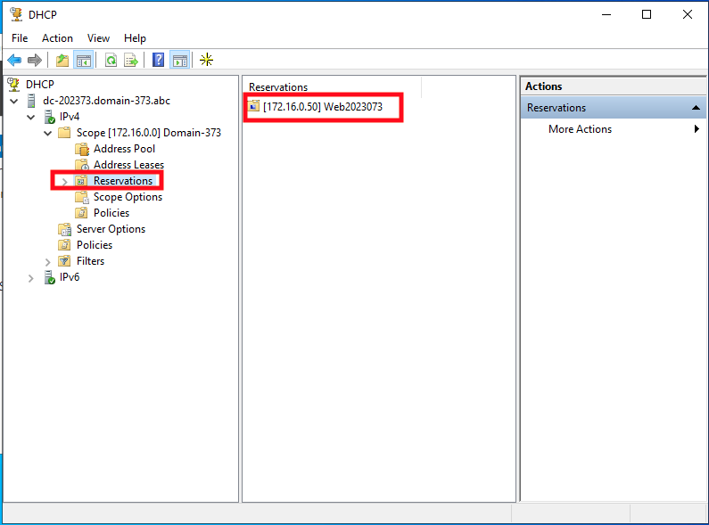

1. Configure the Web computer to dynamically receive the IP address from the reservation instead of using the static IP address (there is information that you will need to obtain from the Web computer).

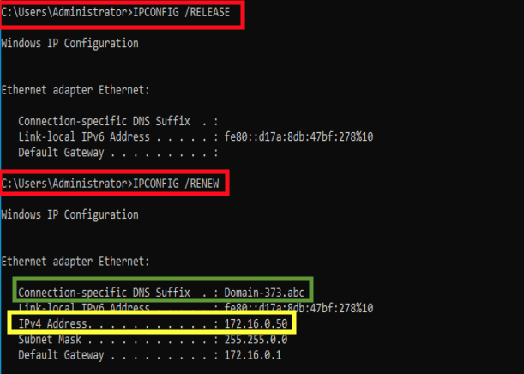

Demonstrate that both computers can still ping each other.

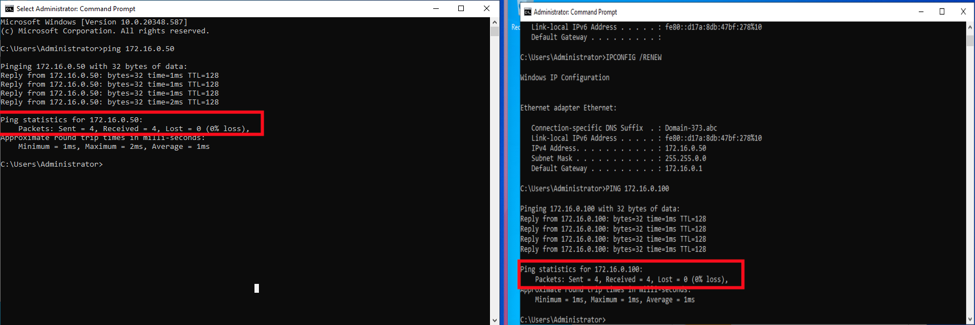

# Configuring RAID on the Web Server.

# Your supervisor at DigiTech is concerned that the files on the Web server could accidentally deleted and they would like to see some fault tolerance added to the Web server computer.

Add six additional hard drives to the Web Server VM to configure some RAID arrays on the Web server.

Currently Drive C: is the main volume on the computer and there is also a Drive D: which is the CDROM drive.

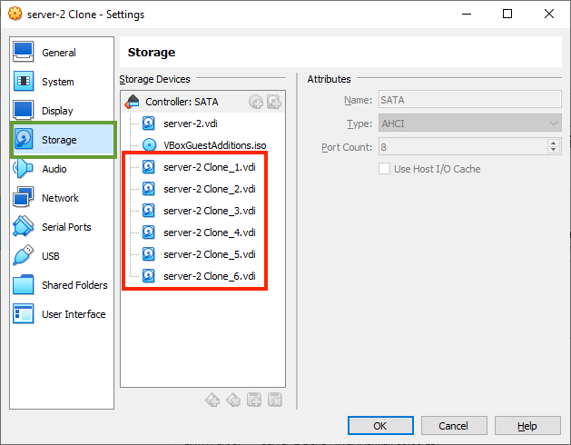

Configure the Web computer to have two new volumes that have this fault tolerance:

1. Use four of disks to create a RAID 5 volume which will be Drive E:

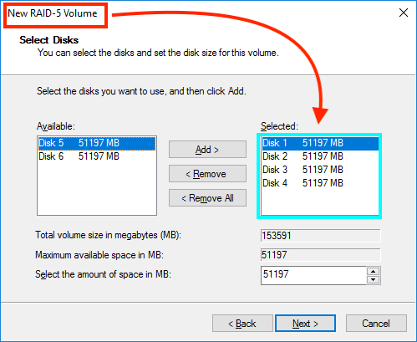

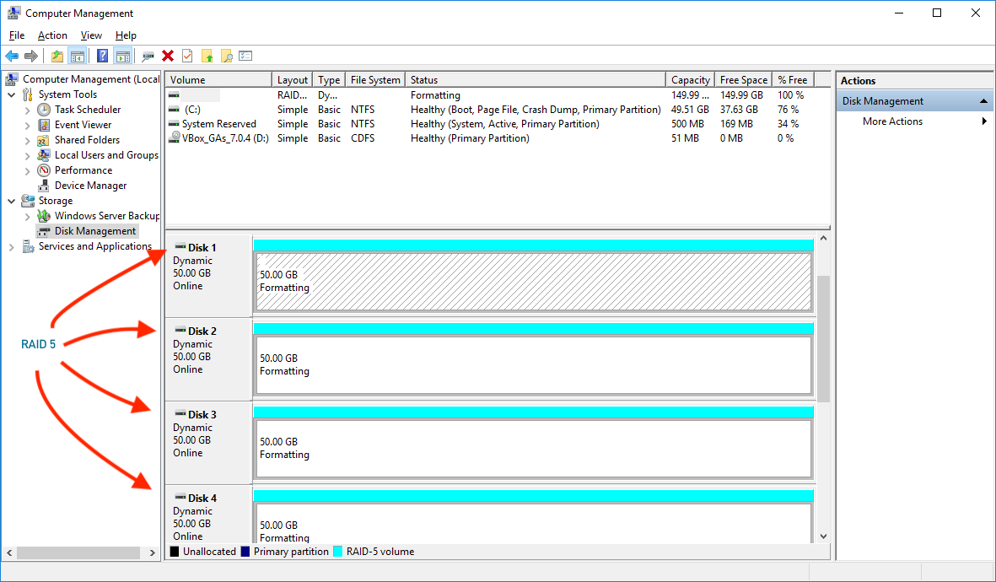

1. Use two of the hard disks to create a RAID 1 Mirrored which will be Drive F:

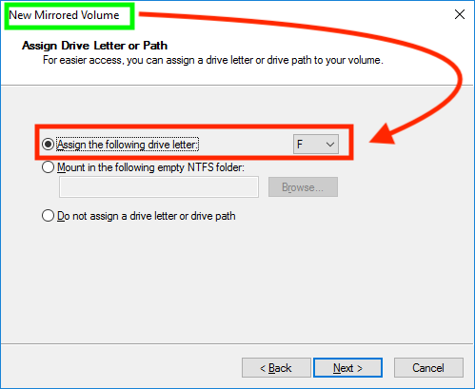

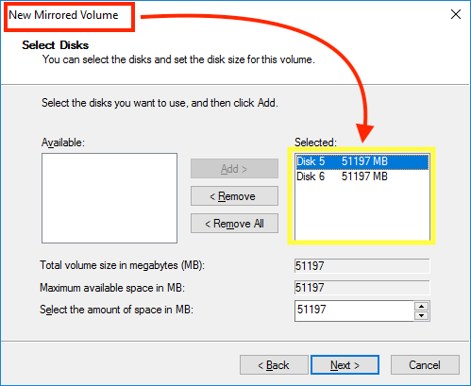

# The tasks above provide a foundation for a network infrastructure.

Below you will find some challenge tasks that build onto of this infrastructure.

## *The IT manager would like each department to have their own custom wallpaper for the user desktop.*

Use the Sale-Department and Accounting-Department JPEG images that are posted on Moodle to set the wallpaper for each department. If a user logs in as a member of the Accounting-Department they should see the wallpaper for the Accounting department as the background on their PC.

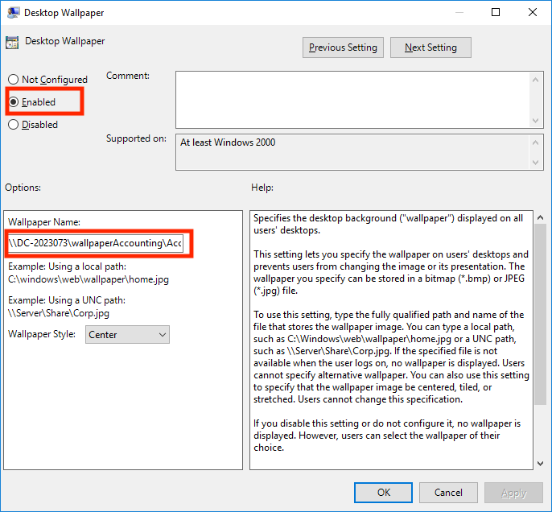

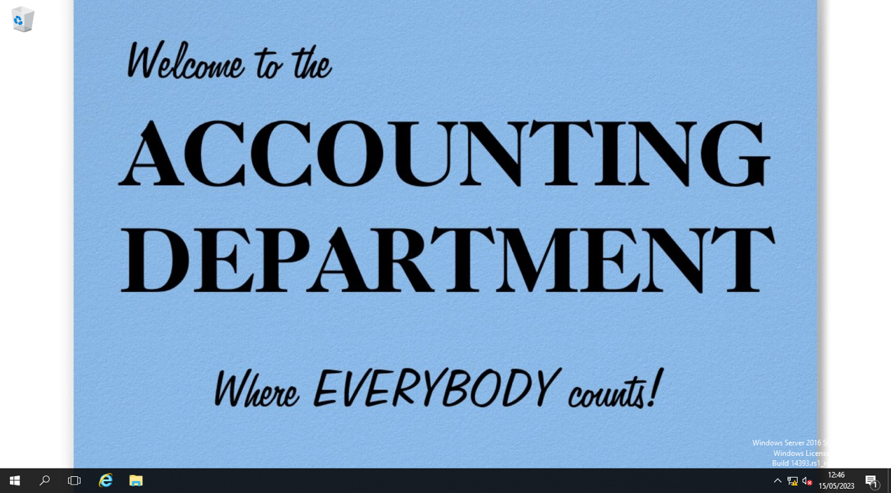

If a user logs on as a member of the SalesDepartment, they should see the wallpaper for the Sales department.

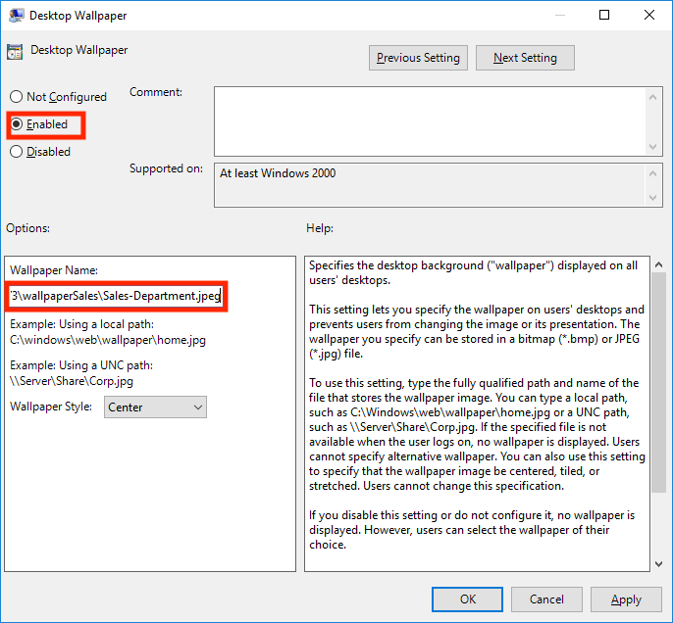

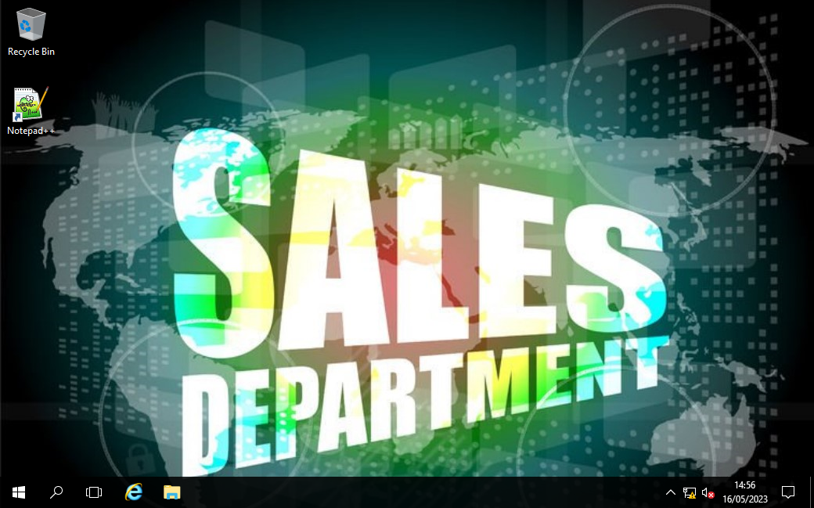

## *The users in both the Sales department and the accounting department have been making unauthorized changes to their systems using the Control Panel.*

The Chief information Officer (CIO) has requested that regular users do not have access to the Windows Control Panel. Use an appropriate method to remove the Control Panel from their desktop.

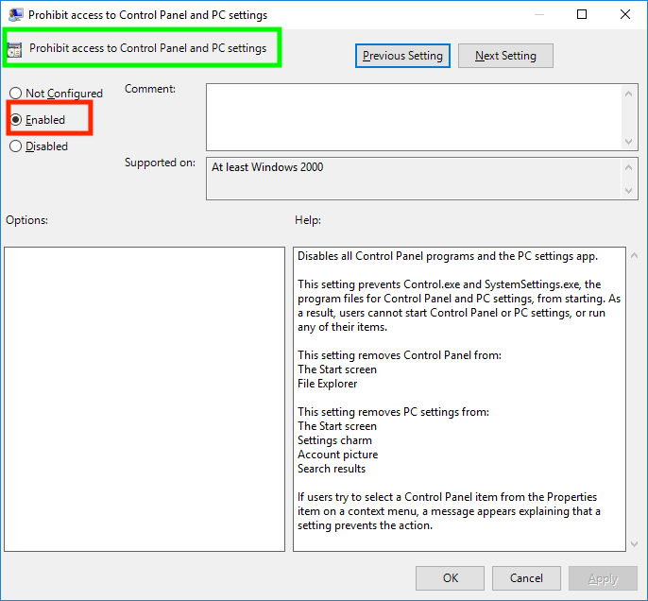

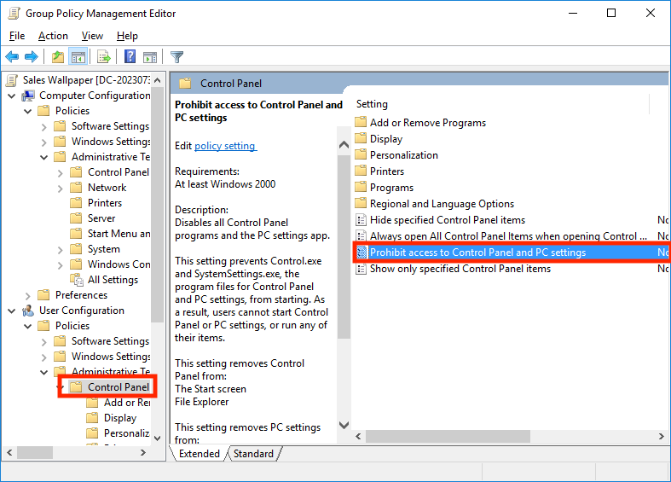

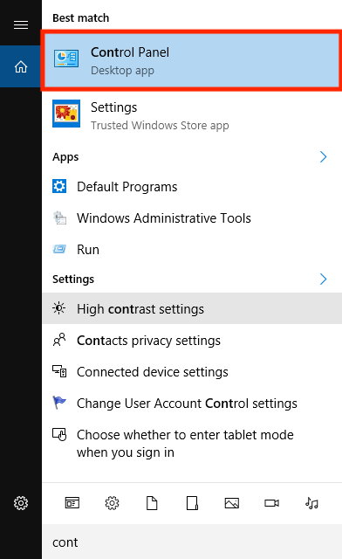

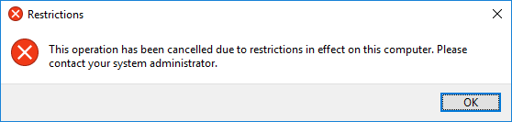

## *Automated Software installation.*

Your IT manager needs you to install software in both the Sales and Accounting departments and she needs you to do this thorough Active Directory. She needs to have Notepad++ available for the Sales department users.

You will need to create a Group Policy attached to the Sales department Organizational Unit. The policy should Assign the Notepad++ software to anyone from the Sales department who logs into the domain.

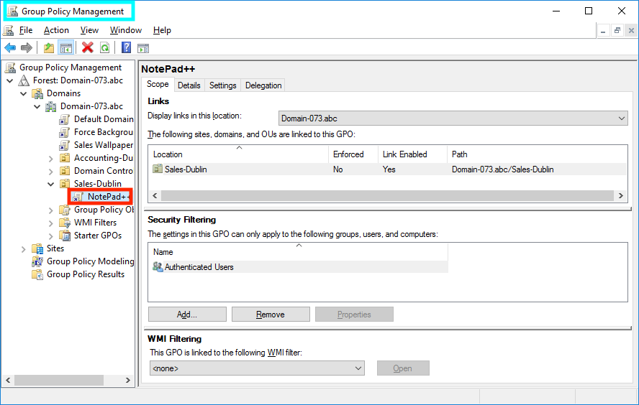

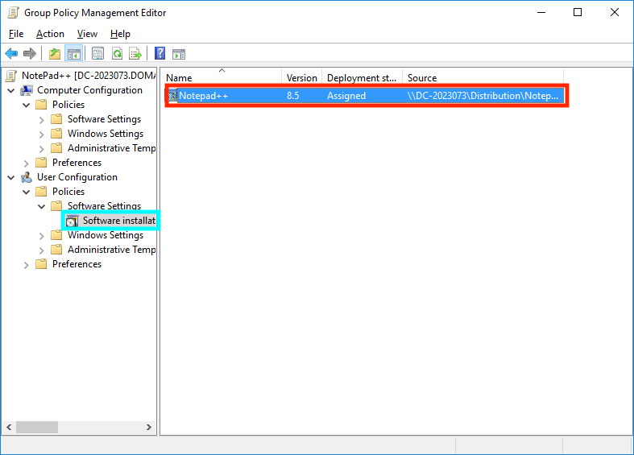

Demonstrate that you have this working by logging into the Web Server as a member of the Sales group and provide screen captures showing that Notepad++ works for a Sales user.

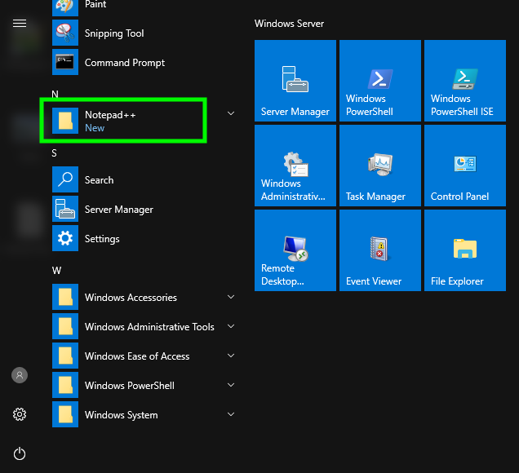

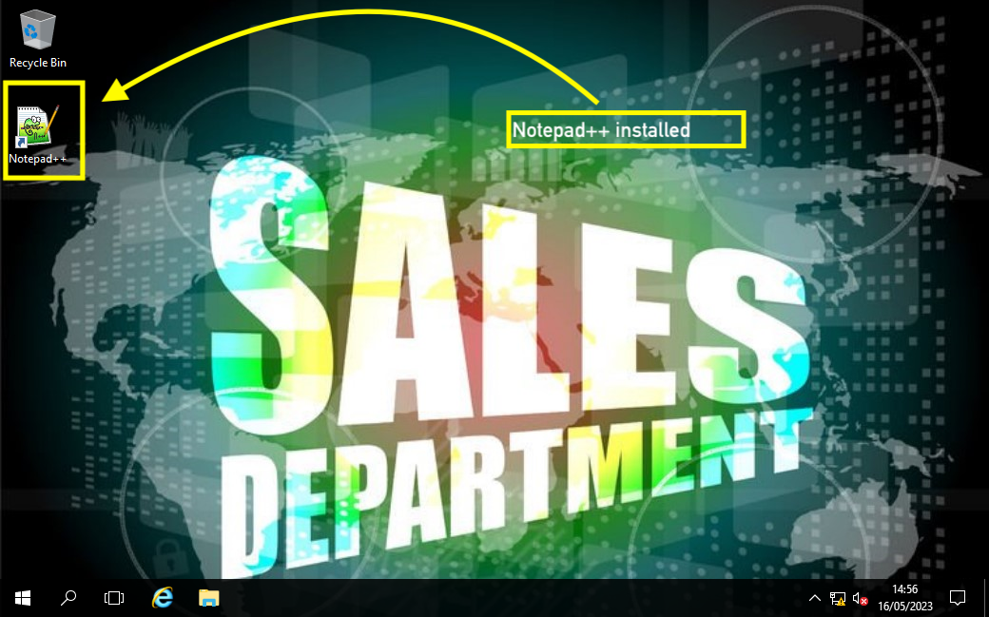

# PowerShell scripting

One final challenge task: This will require some research Your supervisor has heard that you have learned about PowerShell scripting and she is eager to see you demonstrate that you can speed up deployments of adding client PCs to the Active Directory domain by using this PowerShell scripting.

She needs you to create an additional virtual machine for this demonstration. You will name this new Windows Server VM with the name DC-Client.

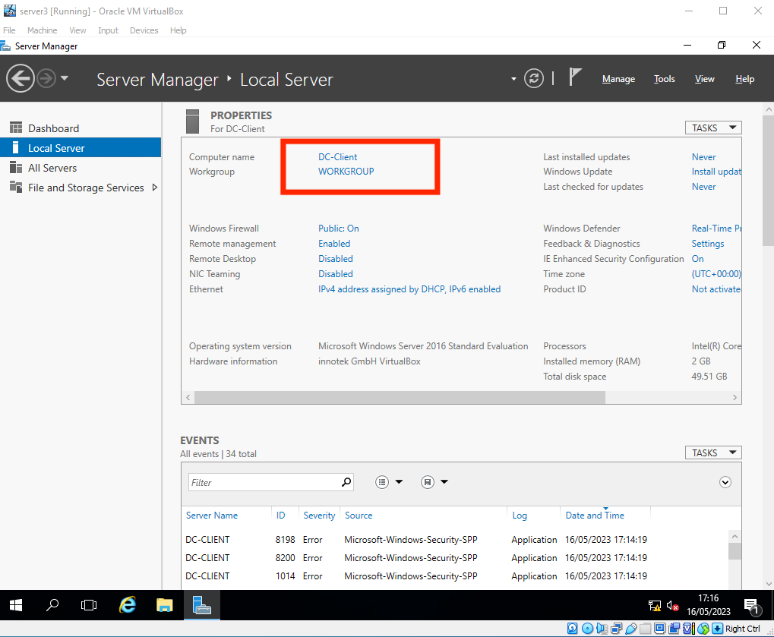

Use the following IP address configuration:

DC-Client address: 172.16.0.175/16 Note: The /16 indicates the subnet mask.

Use 172.16.0.1 as the default gateway.

for the preferred DNS Server address use 172.16.0.100

the alternate DNS Server use 8.8.8.8

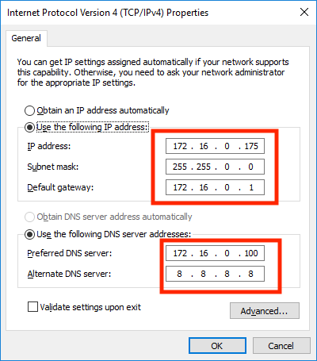

Pinging the VM-Client with the Domain.

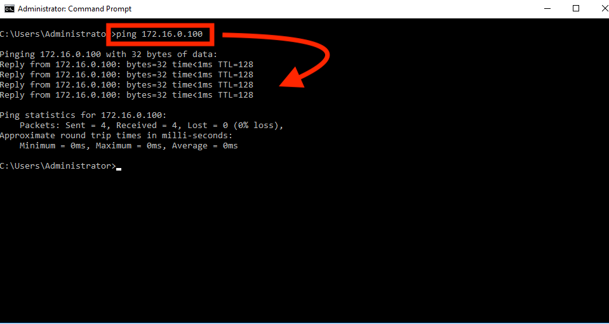

Once you have created this new Server VM demonstrate that you can run a PowerShell Script that will add this Server to the domain when you run the script.

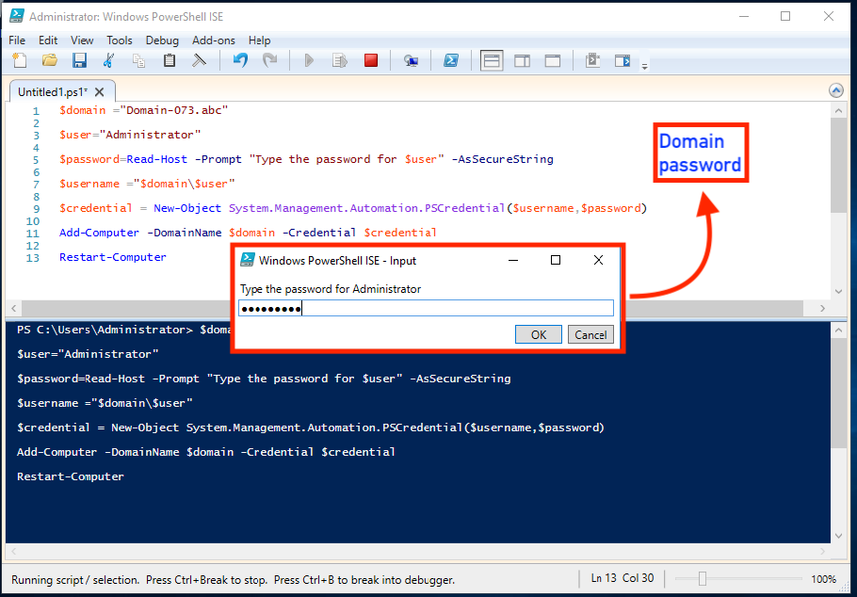

Server added to the Domain.

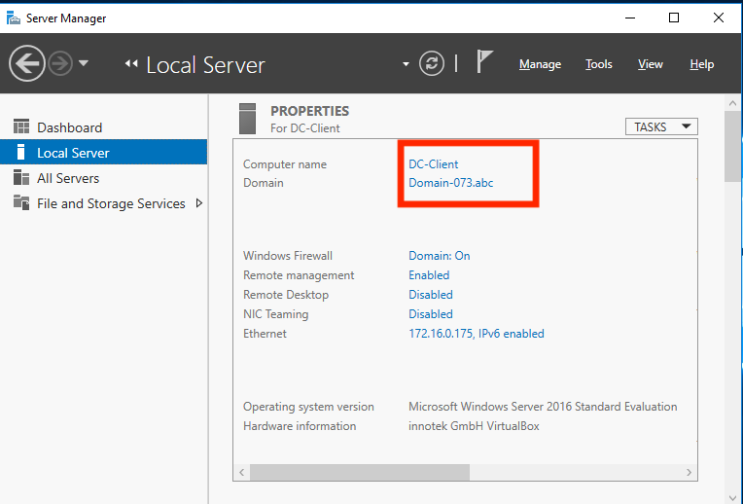

# Challenges:

The project was very lucrative in terms of knowledge, the challenges were amazing, but unfortunately, I ran into a lot of problems, not because the challenges were difficult, it's because the virtual machines use a lot of memory and the devices become very slow and you have reboot virtual machines many times which wastes a lot of time. But I still have to say I enjoyed doing this project.

# References:

*Black Desktop wall paper after implementing group policy* (no date). Available at: <https://social.technet.microsoft.com/Forums/ie/en-US/0c36d7bf-4694-46e1-b408-d644111c0264/black-desktop-wall-paper-after-implementing-group-policy?forum=winserverGP>.

BTNHD (2020) *Join Computer to Domain Using Windows Powershell!* Available at: <https://www.youtube.com/watch?v=hpkicJhhYT8>.

*gpo - deployed wallpaper appearing black in some* (no date). Available at: <https://community.spiceworks.com/topic/2188420-gpo-deployed-wallpaper-appearing-black-in-some>.

*How to apply logon hours to ALL Users in active directory - Microsoft Q&A* (no date a). Available at: <https://learn.microsoft.com/en-us/answers/questions/1115465/how-to-apply-logon-hours-to-all-users-in-active-di>.

*How to apply logon hours to ALL Users in active directory - Microsoft Q&A* (no date b). Available at: <https://learn.microsoft.com/en-us/answers/questions/1115465/how-to-apply-logon-hours-to-all-users-in-active-di>.

*How to deploy Desktop Wallpaper through Group Policy for offline user in Server 2012* (no date). Available at: <https://social.technet.microsoft.com/Forums/en-US/a38dac9d-edd0-41ef-a3f7-b6be3bd0bc12/how-to-deploy-desktop-wallpaper-through-group-policy-for-offline-user-in-server-2012>.

Tech Pub (2019) *How to force a user’s background setting using Group Policy in Windows 2019*. Available at: <https://www.youtube.com/watch?v=c2SAsCcRZt4>.

WebCast, M. (2023) “Deploy Desktop Background Wallpaper using Group Policy - Server 2019,” *Blogs on Windows Server By MSFT WebCast*, 6 May. Available at: <https://msftwebcast.com/2019/08/deploy-desktop-background-wallpaper-using-group-policy.html>.